Ad Personam Promotion 2023

Annexure A: Case for Promotion

Associate Professor A.J. Smit

2023-04-24

# Part 1

## Part 1.1. Candidate Details

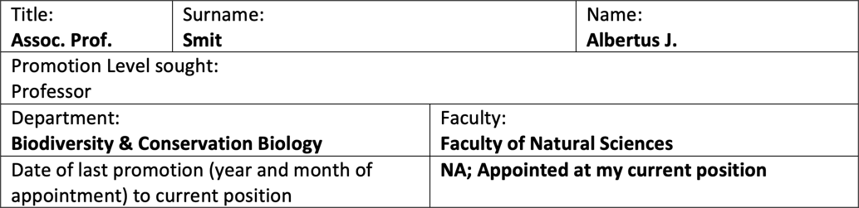

## Part 1.2. Relevant Personal Circumstances

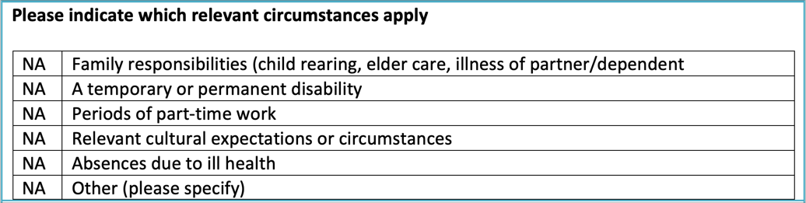

# Part 2. Qualifications and Appointments

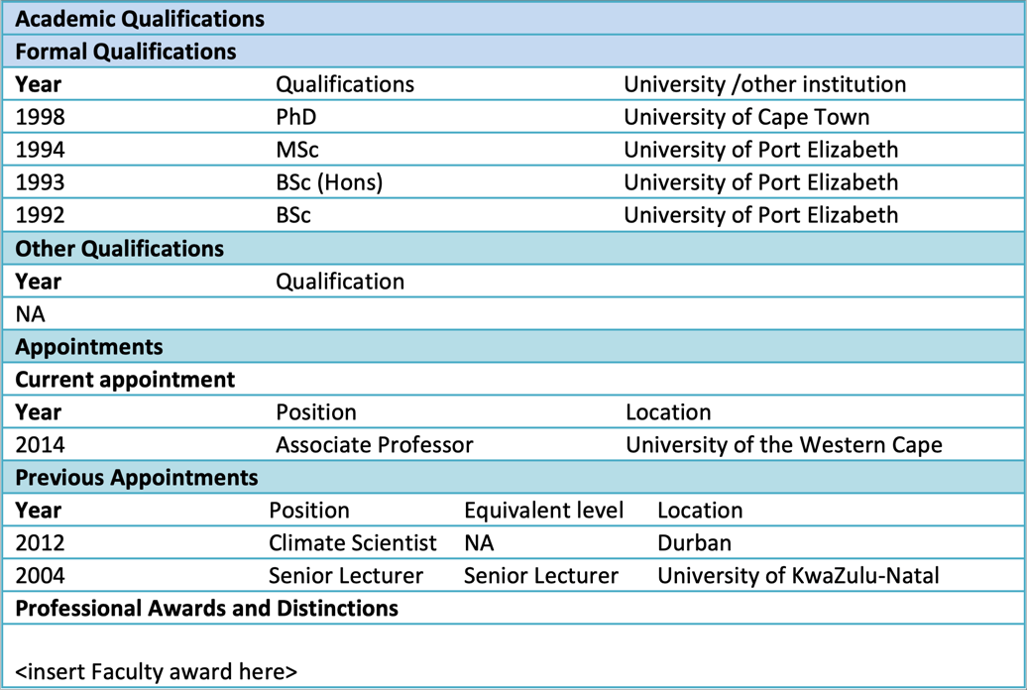

|  |
| --- |
| About this document |
| The **Case for Promotion** document is available in two formats:   * A [PDF version](https://tangledbank.netlify.app/pages/case_for_promotion.pdf) * An [HTML version](http://tangledbank.netlify.app/pages/case_for_promotion.html)   Versions retrieved from the above links will always be more up-to-date until the date of the final submission of this document. |

# Part 3: Career Summary Statement

I am a UPE (now NMU) and UCT Alumnus and academic with 25 years of National and International post-Ph.D. academic teaching and research experience. My academic journey uniquely transcends traditional disciplinary boundaries, setting me apart from my peers.

As an ecophysiologist, I have developed in-depth knowledge of biogeochemical cycles related to nitrogen acquisition in algae and mastered a wide range of associated laboratory and analytical methods. Extended to field biology, ecophysiological expertise broadens to explorations of the processes that govern the flow of minerals through ecosystems and define the trophic relationships among species.

Embracing the role of a climate scientist, I recognised the need to contextualise my understanding of ecosystem processes within the dynamic framework of physical coastal ocean processes. This made me proficient in essential technological advancements, including hardware, software tools, and big data. Consequently, I have harnessed the vast open datasets to produce locally and globally relevant research outputs.

My deep understanding of experimental design principles enables me to efficiently design sampling campaigns that balance robust and representative data collection, financial and field resource constraints, and human capital. By fostering strategic partnerships between academia and external stakeholders, I ensure that my research maintains societal relevance and is executed effectively.

Some colleagues criticise my non-domain-specific research focus. I’d argue that my strength as an Academic lies in my ability to deconstruct complex problems and address them using various tools across multiple academic disciplines. I am comfortable taking field-based and computational approaches. Personal growth flourishes when pursuing new knowledge is a constant driving force. My quest for continuous learning requires an exploration of diverse fields and the synthesis of interdisciplinary insights. In this context, being a generalist holds several advantages over specialising in a narrow research field. A generalist can approach complex problems with a broader perspective, leveraging insights from multiple disciplines to develop innovative solutions. This adaptability fosters a deeper understanding of interconnected systems, promotes collaborative research efforts, and ultimately leads to more impactful and holistic scientific contributions.

I thrive in leading consortia of international collaborators, creating a synergistic environment for ground-breaking research. This versatile skill set has been instrumental in attracting research grants from national and international funders, such as the NRF, Belmont Forum, SANOCEAN, and the European Union. Since 2014, I have secured ZAR 28.74 million in funding to support my research and students.

At the broad level, my research falls within the NRF Broad Category: Biological, Chemical, Earth Marine. It aligns with the National Strategies Grand Challenge – Global Change; Geographic Advantage – Marine and Antarctic Research & Biodiversity; Grand Challenge – Human and Social Dynamics; and Grand Challenge – Bio‐Economy. My research aligns with the UN SDG11 (‘Sustainable Cities and Communities’), SDG13 (‘Climate Action’) and SDG14 (‘Life Below Water’), ticks many boxes concerning several of South Africa’s National Strategies, and benefits from our unique Geographical Advantage.

My generalist views influence my teaching, particularly at Levels 3 and Honours. I practice research-driven teaching, building transferable skills, and promoting the philosophy of reproducible research.

# Part 4.1. Learning and Teaching

Amidst the COVID-19 pandemic, I deftly navigated the situation by implementing innovative teaching methods, which I have been using since 2022. I now offer students a range of options to choose from, including pre-recorded video lectures on iKamva, traditional PowerPoint-type slides, detailed written materials, and in-person lectures. My undergraduate teaching approach revolves around utilising video lectures to deliver content and in-class sessions to stimulate discussion on complex topics while also exploring related subjects and problem-solving. To further engage BSc (Hons) students, I conduct interactive workshops, providing an immersive learning experience. In addition, I developed **The Tangled Bank**,[1] a comprehensive website that functions both as an augmented online textbook and a learning guide. The website serves as a testament to my thorough teaching and learning approach and contains additional information about my teaching methodology, which can be found in the syllabi of specific modules (referenced as footnotes BDC334[2], BCB744,[3] and BCB743[4]). I take immense pride in being a lecturer who goes above and beyond the lecture theatre.

## 4.1.1. Develop Level-3 module BDC334, and BSc (Hons) modules BCB744 and BCB743 for the BCB Department

Drawing upon an extensive history of curriculum development,[5] I have played a pivotal role in revitalising the core BSc (Hons) module, BCB744 Biostatistics, and creating the innovative elective BSc (Hons) module, BCB743 Quantitative Ecology. My deep fascination with biological, ecological, and environmental data forms the foundation of these modules, driving my passion for data processing, analysis, interpretation, and the invaluable insights that emerge from such data-driven inquiries.

The cornerstone of my core and elective BSc (Hons) modules is R, an open-source software ecosystem embraced by ecologists worldwide. The mounting number of research papers and publications in biology and ecology that utilise R and its packages attest to its importance. In academic settings like UWC, Africa, and the least developed countries, open-source software eliminates potential licensing hurdles from limited financial resources. This grants universal access to the software, empowering scientific reporting, collaboration, and the principles of reproducible research while fostering a culture of *technological infusion*.[6]

BDC334 Global Biogeography & Macroecology, another new module for which I take 50% of the credit for its development, is less data-intensive. The module lays the foundations for engaging with species and environmental data matrices from which functional ecological processes can be extracted. Recent feedback from students who completed this module in 2022 indicated that introducing them to more data-intensive coursework and an introduction to fundamental coding skills go a long way to alleviating the anxiety many students feel around coding (scripting). They further indicated that this exposure eased their entry into BCB744, the core module they do at the start of their BSc (Hons) degrees.

A *learning and teaching approach*[7] core of my modules is the principle of collaborative learning, the benefits of which I discuss in my online teaching materials. I use attractive teaching devices to instil an interest in my work. For example, a critical heuristic device I use throughout is figures and maps.[8] The visual fruits of their learning labour are aesthetically appealing and information-rich and, when achieved, provide an instant indicator of success. In this way, students develop programming skills by compartmentalising problems into computable chunks while developing visual literacy skills. This engaging and interactive approach is thoroughly integrated with an *agile assessment policy that evaluates teaching and learning*.[9][10] My modules demystify coding, making it more accessible and enjoyable for beginners.

The skills learnt and the *graduate attributes*[11] developed are designed to produce competencies outside the narrow confines of Biodiversity and Conservation Biology. Transferable core skills include compartmentalising complex problems and finding analytical solutions to problems in diverse fields such as finance, market research, and data science. Many students who graduate with a BSc (Hons) course from the BCB Department will, without requiring further training, have the same skills as someone who has completed a data science course.[12] Many of our graduates will not pursue a research-focused career, yet they would like to continue benefiting from the skills gained at the BCB Department.

Structured outlines of the syllabus, timetables, course content, learning outcomes, required and recommended reading, assessment policies, advice for success (e.g. how to learn to understand[13]), model answers to old tests and exam questions (e.g. for BDC334[14]), and much else, are made available for all modules. During 2023 I will continue to build upon existing content and expand my approach to the other module I teach, BDC223 Plant Ecophysiology.

## 4.1.2. Develop the Tangled Bank website in support of undergraduate and BSc (Hons) modules

I’m not fond of PowerPoint slides, but they structure lectures. I prefer long-form, written, information-rich text for in-depth content.[15] Ideally, I would like to rely on textbooks, but personal textbooks are unavailable to all our students. Information tends to become ‘stale’ quickly in today’s world, which hinders *responsiveness to students’ learning and knowledge needs*. Lastly, students don’t like reading… so I have created (and continue to expand on) ‘The Tangled Bank,’ a teaching-oriented website specifically designed for the needs of students enrolled in my Level-3 and BSc (Hons) modules. Using the website format, I can ensure that I remain agile in updating knowledge and technologies as the scientific landscape shifts ever more rapidly year after year.

The Tangled Bank is my primary lecture content repository and a growing knowledge base for guiding research in my active fields. This website preserves behind-the-scenes insights,[16] contributes to online textbook development, accumulates frequently asked questions about module content,[17] and supports BCB Department modules by incorporating *relevant examples from colleagues’ work*.[18] The Tangled Bank assists peers with module-specific challenges to enhance the learning experience.

Access to long-form written teaching material and the expectation that they read this material play a vital role in preparing students during their undergraduate and graduate degree programs. Long-form content allows for thoroughly exploring ideas, providing context, nuance, and the necessary background for students to grasp intricate concepts. By engaging with comprehensive texts, students can develop a deep understanding of complex subjects, equipping them to think critically and analytically about the material.

In contrast to summarised bullet points, which can simplify and condense information to the end of losing essential details, long-form materials encourage students to immerse themselves in a subject and to consider different perspectives. This fosters (or should foster) intellectual curiosity and a genuine interest in the topic, ultimately promoting a culture of lifelong learning. Long-form content also permits the engaged student to develop a robust knowledge base founded on self-motivated learning. It serves as a solid foundation for their future academic and professional endeavours. This is my wish as a successful teacher.

Moreover, engaging with long-form written material enhances students’ reading and comprehension skills. As they navigate dense texts, they learn to identify the main ideas, supporting arguments, and potential counterarguments. This process hones their ability to analyse and evaluate information, an invaluable skill in academic and professional settings. This skill also needs to be improved in young people today.

By providing students with comprehensive content, I hope for them to develop an appreciation of their chosen field, preparing them for success in their academic and professional lives.

## 4.1.3. Feedback from external (peer) reviewers and students about above modules taught

The following feedback was received from Prof. Sophie von der Heyden for BCB743[19] following her assessment of the module in her capacity of External Module Evaluator for the BCB BSc (Hons) Programme: “*This is an excellent course; I really appreciate that everything is online and very easy to follow. The course is appropriate and challenging at the Honours level, but there also seems excellent support for the students. Really a standout module.” Further, she says, ”There was a wide range of marks, from 45 – 88%, with only one student […] failing this module. Given that students can really struggle with R, it was good to see how well the class did overall. I think part of this is the breakdown into the multiple assignments, which allows students to build on their knowledge as the tasks get more difficult, rather than being overwhelmed with one large assignment.*”

About BCB744,[20] she says, “*As with BCB743, I was very impressed by this course, particularly how easy it is to navigate around the online component. I am sure that the students will be able to access all the necessary components fairly easily. The course is very much at the level of Honours and I hope that for the final projects the students utilize their learning from this course.*”

However, Prof von der Heydon’s comment on the question about whether the marks were assigned appropriately, she said, “*This is a little difficult to comment on as I could not see how the marks were awarded, but given the consistency of marks for each student, I think that the marks are all appropriate.*”

Since the module content is continually being developed, expanded, and improved, I addressed Prof. von der Heydon’s concern about mark allocation by providing clear assessment policies for BCB744[21], BCB743[22], and BDC334.[23] Further, the module content on The Tangled Bank has dramatically improved in all aspects since the modules were last evaluated at the end of 2022.

Feedback from students about the modules is also available.[24] Six students from a class of 14 responded to the module evaluation forms in 2022. Feedback about students’ experience with the module was positive for most of the questions, but 50% of the respondents felt that better feedback could be given to individual tasks. A third of the sample also indicated they felt uncertain about the module’s expectations.

Eighteen students took BCB744 in 2022, and eight provided feedback on the module. As with BCB743, the feedback was similar. Four students felt they could benefit from more comprehensive feedback, and three respondents felt somewhat uncertain about my expectations of them (including the quality of their work). Additionally, two students felt I could better explain concepts and give them more time to understand them. Another negative comment given by two students was that they could be better empowered to explore a variety of sources better to complete assessment tasks.

[To insert feedback received in 2023—will provide once available]

The BDC334 class comprised 41 students in 2022, and only five students tried to provide feedback. One person felt a mismatch between the assessment and the module’s content. Five students thought feedback on individual assessments could be better. There was also one instance of dissatisfaction with the following: sufficient time for communication, my effort to understand their challenges, and uncertainty about expectations. Feedback on BDC223 in 2022 was poor, with only nine responses. Their satisfaction with the module was mixed and polarised into two distinct groups. About 50% of respondents provided much of the same feedback as I received for BCB744, BCB743, and BDC334, and these people felt that feedback on individual assignments could be better. The other half had more negative experiences and I received negative feedback for several other questions. My experience with this class in 2022 was anomalous, as it is singular as the worst class I have ever taught at University. Ever.

[I’m trying to locate earlier evaluations, which appear missing; I’ll provide these once I have located them]

[Insert feedback from teaching assistants: Cayley for 2023 and Jesse for 2022]

[Insert class reviews solicited from BCB744 students]

## 4.1.4. Tangled Bank vignettes and reproducible research

Interdisciplinary research unites diverse skill sets, presenting challenges in teamwork, data sharing, and coding. Greater transparency in research methodologies, such as *reproducible research*,[25] is increasingly important. Adherence to FAIR principles, global standards, and discipline-specific norms is essential. While software offers solutions, many researchers need help to keep pace and embrace new expectations and possibilities.

PhD students typically spend 3-4 months actively writing their thesis, which often becomes the only tangible proof of degree completion. However, most learning and methodological know-how developed during the remaining 33-44 months is often forgotten and unshared, leading to redundant research efforts and limited knowledge transfer. This lack of sharing behind-the-scenes solutions results in non-reproducible research and collaboration difficulties and, in some instances, contributes to the public mistrust of science. It also needs better scalability as datasets and complexities grow and inefficiency due to inadequate documentation of data selection, filtering, metadata tracking, and processing changes.

The Tangled Bank aims to foster the retention and transfer of knowledge, which is key to success in the information economy. To address these issues, my research students create lab notebooks using RStudio or Jupyter Lab/Notebooks and track version changes with git (e.g., GitHub). These notebooks integrate code with text, automatically updating results as new data emerge, ensuring reproducibility in their work.[26][27][28] These same principles are stressed throughout the under- and postgraduate courses I teach. The website also captures some analytical data workflows about which I receive many questions as a series of vignettes.[29] These vignettes will continually be updated, and more examples to document my own and my colleagues’ data and statistical analysis challenges will be recorded here for prosperity.

Other vignettes are at the [heatwaveR website](https://robwschlegel.github.io/heatwaveR/index.html) in the vignettes top menu.

# Part 4.2 Research

## 4.2.1. Successful and prolific funding attraction

Management and leadership experience over the past eight years is evidenced by my high success rate in securing funding from national and international research programmes[30], and the subsequent completion of the programmes according to well‐defined goals and objectives. These research programmes brought in an estimated ZAR 28.74 million for myself, collaborators, and students to support research sustainability since 2014. In the past, I have relied on the NRF as my primary funding source. In recent years I have sought more international collaboration, which is facilitated by accessing global funding streams such as the European Union, the Belmont Forum, and the SANOCEAN programme. These funding streams leverage funding from partnering countries and foster closer collaboration than is typically possible with SA-only funding.

My thinking about the rating system is elaborated on elsewhere.[31] I have yet to find that having an NRF rating benefits securing research funding. I used to hold a C2 rating but let this lapse after due consideration.

My Google Scholar H-index is 29[32] (second highest in the BCB Department) and the site recognises 4072 citations, 2112 of which are since 2018 (accessed on 25 April 2023). Since coming to UWC in 2014, I have averaged ~5 publications per year, and this rate has somewhat dropped since COVID-19.

## 4.2.2. Development of R packages in marine heatwave analysis

One of my most unique and notable research contributions is the development of two R packages, namely **RmarineHeatWaves**[33] and **heatwaveR**.[34] These packages were developed in response to Alistair Hobday and colleagues’ formal definition of marine heat waves in 2016. The algorithm for the detection of marine heatwaves according to standardised metrics, first published as an R package as **RmarineHeatWaves** and then superseded by **heatwaveR** in 2017, has been downloaded at >32k times33 in the international science community and cited >150 times in peer reviewed papers since 2018.[35] An ex-UWC PhD student, Dr Robert Schlegel, and I continue to maintain this package, and we add new functionality to it in response to community needs.

This R package’s impact on the international marine heatwave community must be considered. The standardised metrics make it easier to study these events globally consistently. Previously, the method was only available to physical oceanographers who tend to work in Python, and publishing it in R made it available to biologists and ecologists. This promoted collaboration across disciplines such as oceanography, climatology, and ecology.[36] It is now also being used in fields for which the initial application was not envisaged, outside of the marine realm, such as public health.[37]

Since the reporting MHW metrics is consistent, it improved informed decision-making by policy-makers and resource managers. For example, a better understanding of MHWs helps develop strategies for mitigating the environmental impacts of extreme thermal events and adapting to their effects on fisheries and other marine resources.[38]

Further, **heatwaveR** also led to the development of novel research questions and hypotheses that better analyse and compare MHWs across different periods and regions and employ the metrics to design creative experiments that better link ecological impacts to precisely quantifiable properties of the temperature record.[39]

Finally, the **heatwaveR** package raises public awareness about MHWs and their impacts on marine ecosystems by making it easier for researchers to communicate their findings to a broader audience. For example, the marine heatwave tracker built by Dr Schlegel uses the **heatwaveR** package in the background.[40]

## 4.2.3. Student supervision

My student supervision record is provided in my e-Portfolio.[41] The record indicates 12 BSc (Hons) graduates, 11 MSc/MPhil graduates, and 4 PhD graduates.

Appearing on the online NRF online system as active and continuing are Mr Phumlile Cotiyane, a PhD candidate registered with SAEON’s Elwandle Node whom I am co-supervising, and Mr Ross Coppin, a PhD candidate who has just received overwhelmingly positive feedback from external examiners, and who need to complete some minor edits to my satisfaction.

I have five active MSc students (Ms Cayley Cammel, Mr McQuwaen Moonoosamy, Mr Jesse Philips, Mr Tom Spencer-Hicken, and Ms Carlin Landsberg) and four active BSc (Hons) candidates, Ms Aailyah Samsodien, Ms Zoë-Angelique Petersen, Mr Taine Trimmel, and Mr Isma-eel Jattiem. Since these students receive free-standing bursaries from the NRF, their names do not appear in my NRF database under the list of students associated with my research profile. This also applies to Ms Zara Prew, an active PhD student in my research group. I have had three post-docs in my lab: Dr Rob Williamson, Dr Christo Rautenbach, and Dr David Dyer, and the latter will be with me until December 2023.

Fifteen of the 30 individuals, above, are of previously disadvantaged backgrounds.

## 4.2.4. The South African Coastal Seawater Temperature Network (SACTN)

Related to my interest in marine heatwaves, I have also been instrumental in developing the South African Coastal Seawater Temperature Network (SACTN).[42] This work brings together, for the first time, the disparate seawater temperature records measured over up to 4 decades by the KwaZulu-Natal Sharks Board (KZNSB), Ezemvelo KZN Wildlife (EKZNW), the South African Weather Service (SAWS), the Department of Forestry, Fisheries and Environment (DFFE), the South African Environmental Observation Network (SAEON), and the UWC. [43] This paper has been cited 166 times and instrumental in several other of my own frequently cited publications[44] and stimulated further avenues of research regarding the variability of ocean temperature, including the research on marine heatwaves.

## 4.2.5. Editorial contributions

**2018–present** Associate Editor, Aquatic Botany.[45]

**2020–present** Associate Editor Frontiers in Ecology & Evolution and Frontiers Topic Editor,[46] Managing Deep-sea and Open Ocean Ecosystems at Ocean Basin Scale - Volume 2

In addition, reviewing done for Frontiers in Marine Science; Plos ONE; Proceedings of the National Academy of Sciences; Journal of Phycology; Estuarine Coastal & Shelf Science; African Journal of Marine Science; Hydrobiologia; Journal of Applied Phycology; Journal of Marine Systems; Marine Biology; Marine Ecology; Diversity & Distributions; Ecology & Evolution; Atmosfera; Big Earth Data; Botanica Marina; Environmental Pollution; Science of the Total Environment; Frontiers Ecology And Evolution; Meteorology and Atmospheric Physics; One Health; International Journal of Environmental Research and Public Health, Marine Pollution Bulletin.

## 4.2.6. Committees and programmes

* **2020 – present** SA National Committee for SCOR
* **2018** Invitation, Lead author on IPCC SROCC Report
* **2018 – present** South African Network for Coastal and Oceanic Research steering committee
* **2016 – 2019** President, Phycological Society of Southern Africa (PSSA)
* Eastern Boundary Upwelling System (2022) conference special session host

# Part 4.3 Community Engagement

## 4.3.1. Academic Lead, Kelp Scientific Collaboration PPP

I have been the academic lead of the Kelp Scientific Collaboration[47] consortium since September 2021 (ongoing). The consortium is a Public-Private-Partnership whose intention is to foster collaboration around kelp ecosystems for the betterment of sustainable practices that concern the industry and for scientific advancement on kelp ecological functioning.

## 4.3.2. A research project, funded by SANOCEAN BlueConnect, about the perceived value of South African kelp

This project on the perceived value of kelp[48] was heavily concerned with people’s relationship with kelp and produced several outputs:

* **January 2022** Premier of Akshata Mehta’s movie, *Kelp, South Africa’s Golden Forests* (funded by myself through BlueConnect, and provided concept and oversight).[49] The short film was first shown at the annual PSSA meeting in Arniston and subsequently entered into various nature documentary festivals, including . It is also on YouTube, where it has received 5.3k views.
* **September 2021** Supervise Akshata Mehta’s MPhil Thesis, *“Golden Forests” of the Sea: Assessing Values* and Perceptions of Kelp in the Western Cape Region of South Africa. This work continues to yield stakeholder engagements with community members and the seaweed industry of Southern Africa.[50]

## 4.3.3. BlueConnect engagements

* Contributing author to Chapter 3, UNEP report on global kelp forests.[51]
* Global Ecological Assessment of Kelp, June 15-17, 2022, in Arendal, Norway.[52] This work stems directly from the SANOCEAN BlueConnect Programme, of which I am the South African PI. The work intended to bring together global kelp experts to evaluate kelp forests.
* BlueConnect Kelp Ecosystem 10-day Field Course, 16 – 26 March 2020, Cape Town and De Hoop Nature Reserve – this workshop was affected by COVID-19 and all field work was cancelled; it proceeded as an online course. Ten students from South Africa and Norway participated.[53]
* November 2019: Lead workshop with the kelp industry to gain perspectives about challenges they face about environmental and governance concerns they experience.

## 4.3.4. Other community engagements and capacity-building contributions

I am involved with Cape Nature around capacity-building initiatives targeted at fishermen in the Helderberg region.[54] I am also involved with the Kogelberg Marine Working Group, which aims to discuss and implement conservation management initiatives in the Kogelberg region. [55] I have also been actively training students and young scientists at previously disadvantaged HEIs and NRF National Facilities since 2017; for example, I have taught R courses at the University of Zululand, Walter Sisulu University, SAIAB, and SAEON.

## 4.3.5. CoVID-19 Environmental Research Group

During the first year of CoVID-19 I was part of the CoVID-19 Environmental reference Group (CERG) which aimed to establish the link between seasonality and the prevalence and spread of CoVID-19 in developing countries. An output of the work is the paper Smit et al. (2020).[56]

# Part 4.4 Professional Leadership

Please see Section 4.2.6 under ‘Part 4.2 Research.’

# Part 4.5 Institutional Leadership

* **2016 – ongoing** Level-2 coordinator
* **2016 – 2019** Department Library representative
* **2017 – 2022** Faculty Postgraduate Committee
* **2015 – 2017** Faculty Student Affairs Committee

As a Departmental Postgraduate committee representative, I have several times been part of an initiative to develop an online or automated approach to handling the cumbersome and archaic current approach to dealing with the PG administration process. Various initial attempts have failed due to systemic issues in the UWC system that integrates the various roles that must be part of such a process. Most recently, I have discussed with Prof. Fielding the urgency to revive the process, and we have subsequently held a meeting to initiate a new Faculty process to take forward.[57]

# Part 5. Academic goals for the next three years

UWC is situated in the region where two oceans intersect between Cape Agulhas and Cape Point. These marine environments are influenced by the Agulhas and Benguela Currents. The former is a current that flows along the western boundary and transports heat from the tropics to cooler latitudes. The latter is an eastern boundary system that supports the productivity of one of the world’s most significant upwelling regions. These ocean regions, combined with South Africa’s socio-economic atmosphere, can potentially have a great impact on people’s livelihoods.

The world is going through major changes. The Agulhas Current is becoming wider and carrying more heat, which affects the frequency of marine heatwaves along our coast. Meanwhile, the southern part of the Benguela Large Marine Ecosystem is experiencing localised cooling in some areas. This has a positive impact on kelp forests, causing them to flourish.

My focus is on the coastal and ocean regions, which present valuable opportunities for both teaching and research. I find it particularly exciting as my teaching is closely linked to my research. The scientific landscape is constantly evolving, and the emergence of greater computing power, robust algorithms, and AI, as well as larger datasets, offer immense research opportunities. This will help prepare students for the modern workplace. I thrive intelectually in this environment and continue to develop my online teaching resources. I am inspired to drive and expand my research into extreme marine environmental phenomena, such as temperature, wind, waves, and swell. I am also updating my software, and the release of v.1.0.0 of **heatwaveR** is imminent, which will benefit and accelerate research globally. These tools will also help me narrow down and quantify the ecological significance of kelp forests.

# Referees

Contact Details of at least three (3) referees, two of which must be external to UWC (one must be a character reference)

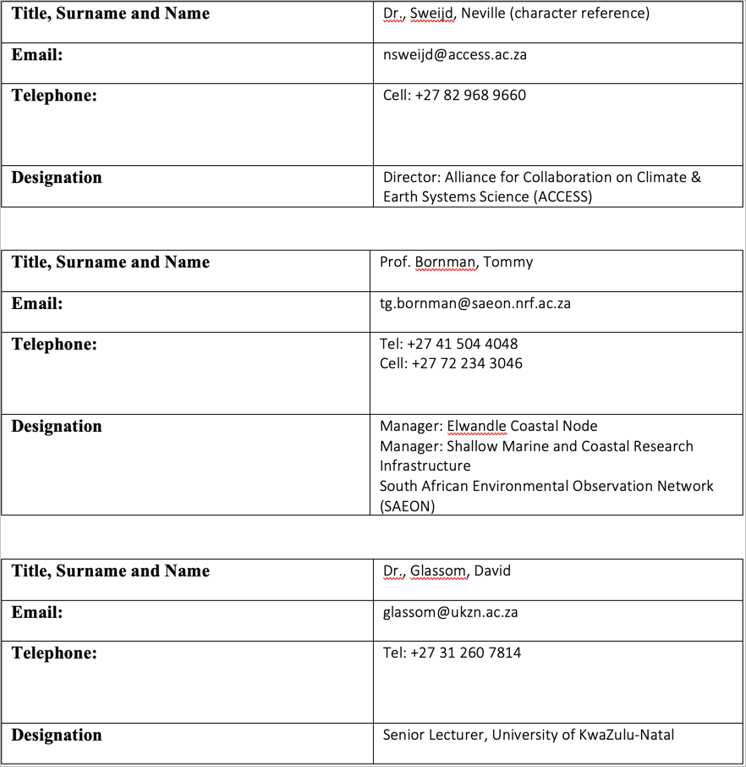

1. [The Tangled Bank](https://tangledbank.netlify.app)
2. Refer to the [BCB744 module syllabus and course outline](https://tangledbank.netlify.app/BCB744/BCB744_index.html)
3. The [BCB743 syllabus and course outline](https://tangledbank.netlify.app/BCB743/BCB743_index.html)
4. The [BDC334 syllabus and course outline](https://tangledbank.netlify.app/BDC334/BDC334_index.html)
5. I was instrumental in developing South Africa’s first undergraduate Marine Biology curriculum at the University of KwaZulu-Natal in 2007 (with Profs. Perissinotto and Schoeman)
6. See a [discussion](https://tangledbank.netlify.app/pages/technology_infusion.html) about how I allow modern technologies to influence and shape my teaching
7. Views on [collaborative learning](https://tangledbank.netlify.app/BCB744/BCB744_index.html#sec-collab-learning)
8. Example [exercises and bonus](https://tangledbank.netlify.app/BCB744/intro_r/09-mapping_rnaturalearth.html#example), designed to reward and incentivise continued learning towards advanced skills
9. [Assessment policy for BCB744](https://tangledbank.netlify.app/BCB744/BCB744_index.html#sec-policy)
10. Explanation of [modes of assessment](http://tangledbank.netlify.app/pages/assessment_theory.html)
11. [Module-specific graduate attributes](http://tangledbank.netlify.app/pages/graduate_attributes.html)
12. The difference between [science and data science](http://tangledbank.netlify.app/BCB744/BCB744_index.html#sec-descr)
13. Thoughts about the [learning process](http://tangledbank.netlify.app/pages/how_to_learn.html)
14. Access to [old test and exam questions](http://tangledbank.netlify.app/BDC334/class_tests.html)
15. For an example of information rich text, see the [example page](http://tangledbank.netlify.app/BCB744/basic_stats/02-summarise-and-describe.html)
16. See the ‘vignettes’ menu at the top of The Tangled Bank.
17. For example, the [FAQ page for BDC223](http://tangledbank.netlify.app/pages/BDC223_FAQ.html)
18. See [feedback from colleagues](http://tangledbank.netlify.app/promotion_docs/Tangledbank_feedback.pdf) about The Tangled Bank
19. Prof. Sophie von der Heyden’s [feedback about BCB743](http://tangledbank.netlify.app/promotion_docs/course_evaluations/BCB743.pdf) in 2022
20. Prof. Sophie von der Heyden’s [feedback about BCB744](http://tangledbank.netlify.app/promotion_docs/course_evaluations/BCB744.pdf) in 2022
21. [BCB744 assessment policy](http://tangledbank.netlify.app/BCB744/BCB744_index.html#sec-policy)
22. [BCB743 assessment policy](http://tangledbank.netlify.app/BCB743/BCB743_index.html#sec-policy)
23. [BDC334 assessment policy](http://tangledbank.netlify.app/BDC334/BDC334_index.html#sec-policy)
24. Student feedback about [BDC223](https://drive.google.com/drive/folders/1-daVKFX6_0adUFdqcGDkx2qe4dJwKNVB?usp=sharing), [BDC334](https://drive.google.com/drive/folders/1-g75ZFDTUbkH67a7ezqSLEKfAtqSJkoG?usp=sharing), [BCB744](https://drive.google.com/drive/folders/1-aT2H-yOrCO3CmO67ga-9IWwGTQENOS0?usp=sharing), and [BCB743](https://drive.google.com/drive/folders/1-c50c13Z2ICrqlZrpXE5uFC0FDxrSFac?usp=sharing) are available at on Google Drive
25. See my essay on eResearch and [reproducible research](http://tangledbank.netlify.app/pages/reproducible_research.html)
26. Dr [Robert Schlegel’s GitHub](https://github.com/robwschlegel) page
27. Ms [Amieroh Abrahams’s GitHub](https://github.com/AmierohAbrahams) page
28. Mr [Ross Coppin’s GitHub](https://github.com/RossCoppin) page
29. Examples of vignettes may be accessed at [The Tangled Bank](http://tangledbank.netlify.app) under the ‘vignettes’ menu at the top.
30. List of [natioanl and international research funding](https://tangledbank.netlify.app/pages/research_grants.html) received
31. My thoughts about [the NRF rating system](http://tangledbank.netlify.app/pages/NRF_ratings.html) and maintaining my own rating
32. See my [Google Scholar](http://scholar.google.co.za/citations?hl=en&user=XFSXRBQAAAAJ) page
33. The [RmarineHeatWaves](https://cran.r-project.org/web/packages/RmarineHeatWaves/RmarineHeatWaves.pdf) documentation.
34. [heatwaveR](https://robwschlegel.github.io/heatwaveR/index.html). Also see the [GitHub](https://github.com/robwschlegel/heatwaveR/) page
35. This number is hard to track, but a search in Google Scholar for the term “heatwaveR” (inverted commas included) yields at least 150 citations. A [shorter list of the citations](https://robwschlegel.github.io/heatwaveR/CITATIONS.html) is provided on the heatwaveR website. Notable examples of high-impact publications are provided [here](http://tangledbank.netlify.app/pages/heatwaveR_publ.html#sec-impact)
36. Examples of cross-discipline research in marine heatwaves promoted by the heatwaveR package are provided [here](http://tangledbank.netlify.app/pages/heatwaveR_publ.html#sec-cross)
37. Evidence of the application of the heatwaveR package outside of the initially intended field of application, marine science, [here](http://tangledbank.netlify.app/pages/heatwaveR_publ.html#sec-outside).
38. For studies that have used metrics calculated by heatwaveR in support of policy development around the management of marine living resources, [see this list](http://tangledbank.netlify.app/pages/heatwaveR_publ.html#sec-policy)
39. Evidence of [examples where such novel research questions and hypotheses](http://tangledbank.netlify.app/pages/heatwaveR_publ.html#sec-novel) have been addressed
40. Various [online trackers of marine heatwaves](http://tangledbank.netlify.app/pages/heatwaveR_publ.html#sec-trackers) use heatwaveR as the underlying processing engine
41. Extract from the [NRFOnline system listing most of my post-graduate students](http://tangledbank.netlify.app/promotion_docs/PG_supervision.pdf)
42. The The South African Coastal Seawater Temperature Network [(SACTN) GitHub](https://github.com/ajsmit/SACTN) page from where data can be downloaded
43. [Smit et al (2013)](https://journals.plos.org/plosone/article?id=10.1371/journal.pone.0081944)
44. [Schlegel et al (2017a)]((https://www.sciencedirect.com/science/article/pii/S0079661116300830)) and [Schlegel et al (2017b)]((https://www.frontiersin.org/articles/10.3389/fmars.2017.00323/full))
45. Associate Editor for [Aquatic Botany](https://www.sciencedirect.com/journal/aquatic-botany/about/editorial-board)
46. My Reviewer’s profile on Loop for editorial contributions to [Frontiers in Ecology & Evolution](https://loop.frontiersin.org/people/137774/overview)
47. [Kelp Scientific Collaboration mission statement](http://tangledbank.netlify.app/promotion_docs/Kelp_collaboration/KelpCollaboration_MOI.pdf)
48. [Perceived Value of Kelp](http://tangledbank.netlify.app/promotion_docs/Akshata/GoldenForests2_AM.pdf)
49. [Kelp, South Africa’s Golden Forests on YouTube](https://www.youtube.com/watch?v=RuAO304Ip1s)
50. [Akshata Mehta’s MPhil thesis](http://tangledbank.netlify.app/promotion_docs/Akshata/Thesis_AM.pdf)
51. [United Nations Environment Programme, & Norwegian Blue Forests Network (2023). Into the Blue: Securing a Sustainable Future for Kelp Forests.](https://wedocs.unep.org/handle/20.500.11822/42255;jsessionid=959A1D86A4D90ECDA74D5113F4AC44F5)
52. [Invitation letter to the GEAK workshop held in Norway](http://tangledbank.netlify.app/promotion_docs/BlueConnect/GEAK-Blueconnect%20letter.pdf)
53. [BlueConnect March 2020 Field Course](http://tangledbank.netlify.app/promotion_docs/BlueConnect/Field_Course_combined.pdf)
54. See most recent invitation to [participate in a capacity building initiative](http://tangledbank.netlify.app/promotion_docs/Cape_Nature/Fishermen_capacity_building.pdf)
55. Invitation quarterly [Kogelberg Marine Working Group meeting](http://tangledbank.netlify.app/promotion_docs/Cape_Nature/Kogelberg_Marine_WG.pdf)
56. [Smit et al (2020)](http://tangledbank.netlify.app/promotion_docs/CERG/Smit_et%20al_2020.pdf) about CoVID-19
57. Various [contributions](https://drive.google.com/drive/folders/12KbDb0JODFnuR6sWd45b4xmXZctXaDNS?usp=sharing) to initiatives that attempted to solve the PG administration process. See specifically my [latest plead to reinstate the planning and development process](https://drive.google.com/file/d/12Wy7Ou9u56dsroHVmgGQREd8Ymo-OACF/view?usp=sharing)